April 2025 Report

Raytheon Technology Corporation (RTX)

Paul Reilly

Company Overview

Raytheon Technology Corporation is a leading aerospace and defense company based out of Arlington Virginia. RTX Specializes in the manufacturing and engineering of technologically advanced aircraft engines, missiles, and radar systems for military, commercial and business purposes. The company is made up of three divisions, them being Pratt & Whitney, Raytheon, and Collins Aerospace. The aerospace and defense industry has faced a rapid increase in demand in recent years due to both geopolitical tensions and the race to implement modern day AI aerospace and defense systems into both military and commercial operations. RTX demand and output can be expected to remain high in coming years and they currently have a $218 billion backlog, indicating a strong consumer trend.

Key Metrics

* Market Capitalization: 171.466B
* 2024 Total Revenue: $81B (9% increase YoY)
* 2024 Gross Profit: $15.5B
* P/E Ratio: 36.20

The current P/E Ratio sits well below the Aerospace & Defense industry average of 67.66. This information does indicate that RTX is potentially undervalued and holds a healthy financial standing. However it is important to note that companies of similar caliber and size in the industry such as GE Aerospace (GE) and Lockheed Martin Corporation (LMT) have similar P/E Ratios of 30.76 and 20.70, respectively.

Company Strategy and Focus

RTX’s primary focus is to capitalize on surging demand for missiles, defense systems, and radars by increasing production rates. In order to provide the most innovative products and services RTX puts a focus on research and development, specifically the development of hypersonic missiles, a product that has seen a surge in demand as a result of geopolitical tensions and political uncertainty. The aerospace and defense market grows at about 6.7% annually, signifying consistent market growth and need for innovation due to competition.

The $218 billion backlog and increasingly high demand is in no way overlooked as RTX has made strategic investments and addressed constraints in order to deliver capabilities more quickly. Raytheon has established contracts with Northrop Grumman and Nammo to scale MK72 rocket motor production as well as build new production lines. Although Raytheon is outsourcing a portion of their production to other manufacturers, this positioning will allow them to increase capacity and source options. As global demand rises and other defense companies supply also under strain such as the Boeing Company with a $435.18B backlog, Raytheon making the investment to expand supplier base will pay off significantly in the future.

Earnings

For 2024 Raytheon presented impressive earnings growth with reported sales of $80.7B, up 9% YoY and adjusted earnings per share of $5.75, 13% increase YoY. CEO Chris Calio attributed the sales increase to segment expansion over all three businesses, (Collins Aerospace, Pratt & Whitney, and Raytheon). Future earnings are projected to continue to increase as the company believes they have a strong momentum heading into 2025 with a $218B backlog and unprecedented demand. As of now RTX forecasts 4-6% sales growth for 2025

Schlumberger (SLB)

Chase Boddison

Schlumberger is an oilfield services and energy technology multinational corporation leading globally that is specialized in drilling, reservoir characterization, production, and processing. The company was established by French brothers Marcel and Conrad Schlumberger in 1926 and has operations across over 100 countries with a workforce of about 111,000 as of 2024.

Technological Innovations and Operations

SLB has never stopped innovating in energy technology, both in traditional oil and gas services and new energy solutions:

* Autonomous Drilling: SLB has led the development of autonomous drilling technologies, achieving a 60% increase in drilling rate on a project in Brazil. The technology enhances operation efficiency and safety by reducing onsite manning requirements.
* Direct Lithium Extraction (DLE): SLB launched a commercialized DLE system in 2024 after successful pilot runs in Nevada. The technology is capable of extracting lithium with higher efficiency and sustainability, fulfilling the growing demands for electric vehicle batteries.​
* Artificial Lift Systems: SLB introduced new artificial lift systems, including the Reda Agile electric submersible pump (ESP) and rodless Reda PowerEdge electric submersible progressing cavity pump (ESPCP), to streamline oil production and make it more reliable.
* Digital Integration: The business has expanded its digital solutions via partnerships, such as with IBM and Red Hat, to develop hybrid cloud solutions for the energy sector, facilitating enhanced data management and operating efficiency.

Financial Performance (2024)

SLB demonstrated strong financial performance in 2024:

* Revenue: $9.28 billion for Q4, a 3% year-over-year increase.
* Net Income: $1.10 billion for Q4, with good profitability.
* Adjusted EBITDA: $2.38 billion for Q4, demonstrating effective operating performance.
* Earnings Per Share (EPS): $0.92, before charges and credits, up 7% year over year.​
* Free Cash Flow: $3.99 billion for the year, enabling meaningful shareholder return and debt repayment.

These figures demonstrate SLB's financial strength and advancement.

Future Outlook

SLB is positioned to lead the evolving energy landscape:

* Energy Transition: SLB's investment in technologies like DLE and autonomous drilling illustrates global trends toward sustainable energy solutions.
* Digital Growth: With greater digital integration, SLB will be in a position to increase operational efficiencies and offer next-generation solutions to clients.
* Positioning in the Market: SLB has been viewed as undervalued by analysts, with its technology and global presence leaving scope for long-term returns.
* SLB's innovation and sustainability orientation place it at the forefront of meeting the world's growing energy needs while ensuring environmental responsibility.

# Crypto sentiment during COVID-19 v. Tariffs

Sean Murphy

Crypto Pre-COVID

After making all time highs in late 2017, Bitcoin entered a bear-market for the duration of 2018, before bottoming in December of 2018. Throughout 2019 Bitcoin recovered, swinging from $4,000 to $14,000, then down to $7,000 by year end. Around this time, narratives of Bitcoin as a hedge against inflation started emerging, and the idea of crypto futures and etfs were circling the financial world.

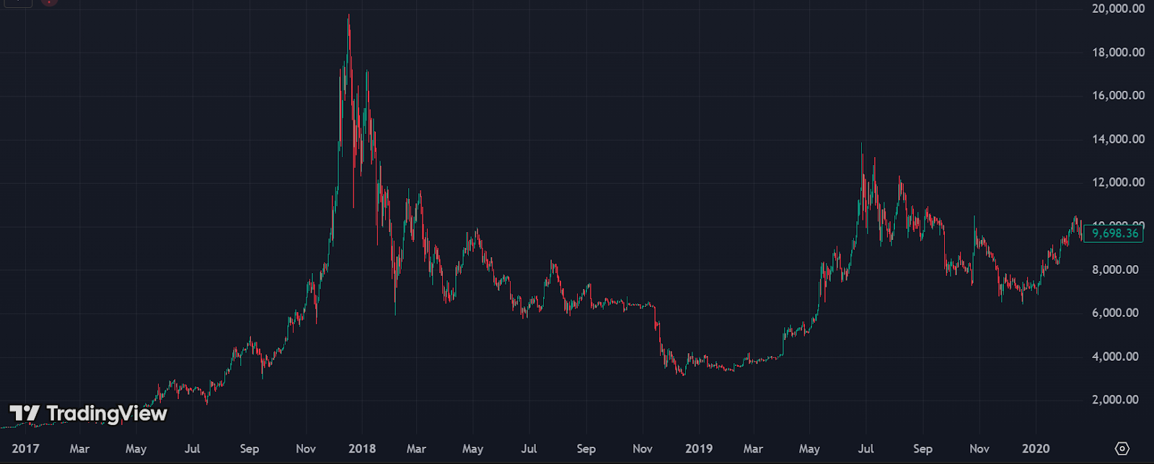

*This is the Bitcoin chart from 2017 to late February 2020. Notice the strong run in 2017, followed by the bear run in 2018, and the recovery in 2019.*

The COVID Crash

Throughout January and February of 2020, we watched Cronavirus spread faster and faster. Public news events such as the cruise ship outbreaks, garnered massive media attention and began scaring investors. From late February to mid-March, we watched markets get wiped out worldwide. The S&P 500 dropped 36% in 33 days, and Bitcoin dropped 63% in 29 days.

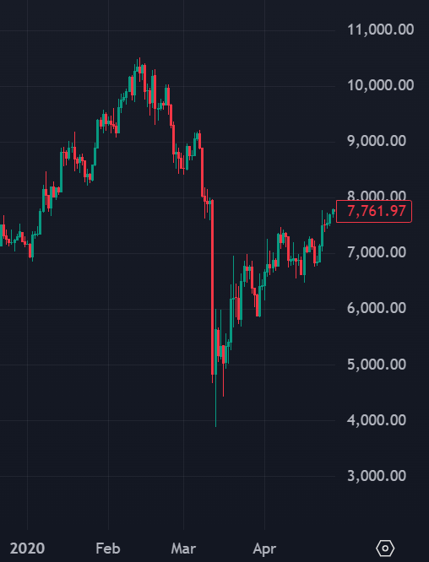

*High: Feb 14th - $10,510, Low: Mar 13 - $3,883*

Bitcoin Crash

As COVID surged, economies and countries shut down, and Bitcoin crashed. After rallying back up to a price of over $10,000, Bitcoin would crash all the way down to less than $4,000, a more than 60% drop. The S&P 500 in the same time dropped over 30%. Bitcoin and crypto as a whole dropped exceedling low due to leverage traders getting liquidated and panic selling leading to liquidity and slippage issues, which only further dropped the price. Keep in mind that Bitcoin dropped before the stock market and bottomed out before the stock market. Note how Bitcoin dropped twice as much as the stock market. I will come back to this further in the report.

The 2021 Bull-Market

After COVID shut entire economies down for weeks to months, governments across the globe printed trillions upon trillions of dollars to attempt to stimulate and maintain their economies. Along with this the FED cut rates down interest rates to zero and began large scale asset purchasing. This rapid government effort to attempt to maintain economies led to mass uncertainty of the long term potential effects of printing such a quantity of money. This led to widespread fear of inflation, currency debasement, and long-term debt problems. Around the time of these fears spreading, narratives of Bitcoin emerging as “digital gold” started lingering across the public. Bitcoin’s fixed supply and decentralized nature is the perfect investment to make after your government prints over 3 trillion dollars. Along with this, major financial service companies began offering crypto services. Fidelity, BlackRock, and JP Morgan launched crypto-focused services and Robinhood gave users the ability to trade a variety of crypto currencies on their platform. Stimulus checks, an erosion of trust for fiat currencies, and new platforms making trading crypto easy and lead to the 2021 bull-run. 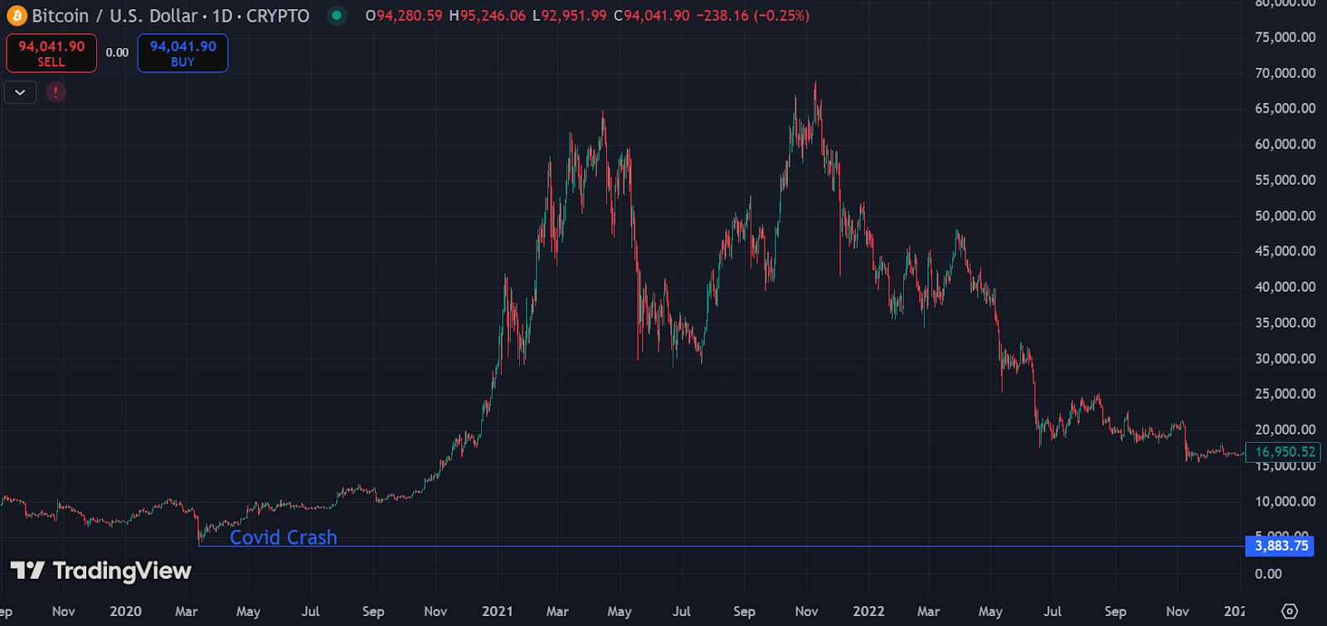

*Bitcoin bottomed at 3,800 after the Covid Crash and then peaked at 69,334 600 days later on Nov 10th, a 1,609.5% return. Over this time the market cap of cryptocurrency went from 750 billion to 3 trillion*

Sentiment Pre-Tariffs

Generally with Republican presidents, investors expect more pro-business policies, such as: corporate tax cuts, deregulation, and a focus on U.S. manufacturing. In January, Trump held a “crypto-ball” where speakers discussed the crypto future of America and how the U.S. was going to lead the globe in crypto adoption. Along with this, the stock market continued to make all time highs riding on tech stocks and the promise of AI. Markets expected Trump to focus on immigration and strengthening the U.S. economy, which was bullish for crypto and the equity market.

Tariff Crash

On February 1st, Trump announced U.S. tariffs imposed on Canada, Mexico, and China, the market reacted with extreme volatility. None of these countries reacted well to this announcement and levied tariffs back on the U.S. After the announcement of these tariffs and the reciprocal tariffs, the market began crashing. Fueled by uncertainty, investors were quick to pull their money from the market.

Bitcoin Crash:

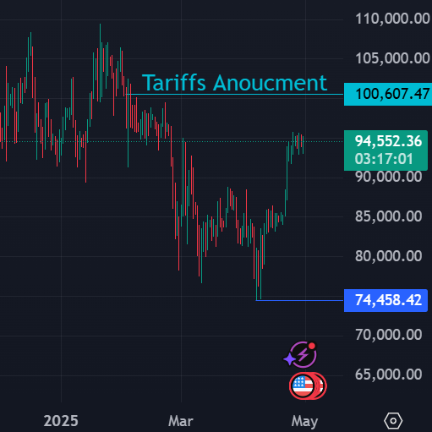

*Tariff Announcement: Feb 1st - 100,607*

*Bottom: Apr 7th - 74,500*

Unlike the 2020 crash, during the tariff crash Bitcoin was fresh off of an all time high of over 100,000. Still Bitcoin fell 25% after the tariff announcement and bottomed at ~75,000. Uncertainty over trade wars and a looming recession caused investors to sell their Bitcoin and other assets. In a similar fashion, the S&P 500 dropped 20% bottoming around the same time as Bitcoin. This is a stark contrast to the Covid crash as Bitcoin crashed twice as far as the stock market did then, and now followed a very similar level of correction to the stock market. I will discuss the significance of this further in the report.

Recovery

Since the bottom of Bitcoin and the S&P 500 on April 7th, both assets have recovered significantly. Since the bottom, the S&P 500 is up 15%, while Bitcoin is up 28%. Market sentiment is turning around due to the threat of tariffs and trade wars settling down. As we look to the future, both the stock market and crypto have entered a recovery phase as volatility subsides and investor confidence cautiously returns.

Takeaways:

Crypto in Volatile Conditions

An important fact to understand when looking at crypto markets is how investors react to volatile market conditions. Think of investing in crypto like shopping at Whole Foods. While being more expensive, you also can enjoy more healthy food for yourself and your family. But if you were to lose your job and face financial uncertainty, you are better off shopping at Walmart and saving some money as you are unsure of when you will receive that next paycheck. To most investors crypto is like Whole Foods, a luxury where you pay more (take on higher risk) for higher quality food (higher potential returns). So when facing economic uncertainty like potential trade wars or a recession, it is smart to put your money in less risky assets. Understand that investors will be quicker to take their money out of crypto as it is seen as a more volatile, more risky asset. This will often lead to sharp crypto drops in volatile conditions. Notably, with the tariff crash, Bitcoin and the stock markets correction was practically the same and the recovery is following the same path. This is showing that crypto has grown to the point where it more closely follows the market and macroeconomic trends, which is bullish for crypto as it is showing crypto now is working with the markets and not just in euphoric bull and demoralizing bear cycles.

Understand Crypto as an Asset

You also need to understand there are two reasons to invest into crypto as an asset. The first reason is that you believe in the future of crypto. You believe we will be paying with crypto in person and online, you believe that blockchain technology will revolutionize how we process transactions, and that Bitcoin **IS** digital gold. Overall, you believe that we are still in the early stages of crypto’s integration and adoption. If this is you, you should be buying, holding, and never selling. If not, crypto can still be a good asset if you can time the market and understand retail investors. Retail investors dominate crypto markets and are often the driving force behind major price surges. Even when experienced traders are sidelined holding, it’s retail enthusiasm, not institutional conviction, that sends prices to euphoric highs. Understand that in order to make money in the crypto market, you **NEED** to be buying when people are fearful and selling when people are euphoric. When crypto momentum begins you need to be positioned accordingly, and when your parents and cousins are asking about, “this crypto thing” it is time to sell.

Solana (SOL)

Sean Murphy

Overview

Solana is a blockchain platform designed to support decentralized applications and smart contracts. Launched in 2020, it aims to provide high-speed and low-cost transactions. In comparison to the two biggest networks in the space, Bitcoin and Ethereum, Solana has significantly lower fees at two cents per transaction and significantly faster. This is compared to Bitcoin which has fees that can exceed 10 dollars and Ethereum which has fees typically between 50 cents to 5 dollars. Solana also has much faster transactions per second at around 65,000 and a transaction finality of 2-5 seconds, Bitcoin has the capacity to handle seven transactions per second and has a finality of roughly an hour and Ethereum has a TPS of 15-30 and a finality of 12-15 minutes.

Changing Market conditions

Solana has recently taken a massive hit going down from a price of nearly $300 to now trading around at a price of around $130 (2/28/25) within a little over a month. But why? There are many potential factors that could be causing this dip. One factor has been the uncertainty of tariffs with the new Trump administration. But this dip hasn’t been on just Solana, but also the rest of the crypto market and the stock market. Another factor is the recent hack of the crypto exchange By-Bit, where North Korean hackers stole over 1.5 billion dollars of Ethereum which was the largest single theft in human history. Although there is a lot of uncertainty in the crypto market, Solana still is absolutely an asset that should be on your radar.

Why Solana?

While Bitcoin and Ethereum have set themselves apart as the two biggest assets in the crypto space, they can only be used as payment methods and even then, they are far from the best at that. Along with us, nearly all crypto experts concur that we will soon reach a point where you will be able to pay for your groceries using crypto and the giants BTC and ETH will not be the platforms this payment system is built on. Stores would not be willing to wait ten to sixty minutes before they can confirm their purchase, but rather they would use a block-chain like Solana where they can quickly confirm the transaction without having to pay large fees, and this is what sets Solana apart, consumer utility.

Utility

Solana currently stands as the block-chain, as the most utilized transaction asset. What is utility? While discussing utility in the crypto space, utility is the use case for crypto assets outside of an investment. For example, the utility of Bitcoin is the ability to send money to people across the globe without government centralization. Solana sets itself apart because of all the utility it currently possesses and has the capability to possess. The first and most notable utility Solana has is the ability for any individual to create their own token within a matter of clicks. We saw this craze begin during the end of 2024 and explode after Trump released his own meme coin in January of 2025. Another notable feature of Solana is its use case for NFT’s. SOL has set itself as the best platform for building NFT projects. While NFTs had a massive craze in early 2022, the utility of being able to claim and prove a digital token is yours is a massive concept that is yet to be used to its fullest potential. A new addition to SOLs utility has been Wormhole, which is a new service where using the Solana block-chain you are now able to bridge any crypto to Solana and then to any other crypto. This is a massive service that continues to help Solana stand apart from the rest of the market. Lastly, another major piece of utility for Solana is their new service Roam. Roam is a novel piece of technology that plans to solve the problem of insecure and unstable public Wi-Fi. Roam is set out to bridge all public Wi-Fi networks into one service where wherever you go on the globe your devices will automatically be connected to free public Wi-Fi, while being safe and secure. This massive innovation that will potentially be used by the entire globe is being built on Solana. While these are only a few of the utility aspects of Solana there are still countless others that we’ll discuss in future reports.

Why We’re Investing for The Future

We are personally investing for countless reasons. For one, Solana has stood out as having the most used and potential utility in the entire crypto market. Secondly, the meme coin market. While everyone should be avoiding meme coins at all costs, you can still profit off them by owning Solana (and it can be quite fun.) This is because nearly all meme coin transactions are being made with Solana, this means people are constantly buying large amounts of SOL and then when they sell their coins, they are receiving SOL. Lastly, as Solana currently stands in the market, it is incredibly undervalued. Even when SOL was trading at all-time highs, we still felt it was undervalued. The utility is massive, and its market share is far too small for all SOL brings. With all this being said, investing in crypto in today’s uncertainty, you should not be making a one-time purchase for all you are willing to invest. We are personally dollar cost averaging each investment, as the crypto market is extremely volatile and can have massive down or upswings.

The Privatization of Student Loans

Lucas Kopp

Shutting Down the Department of Education:

A continuous relief on Student Loans that began during the pandemic ended last year in October, with many students falling behind on payments. This issue has persisted for the last decade and federal student debt has grown over 50% in the last 10 years to around 1.6 trillion dollars. This comes as the Trump administration could make a move to privatize student loans, a goal for conservatives since the Department of Education (DoE) began in 1980. The Department of Education looks to be one of the Trump administrations next targets in cutting costs and pursuing a balance budget by the end of his term. Federal funding for schools and government backed student loans would largely disappear, leading to a gap in education-related finances. This report will focus on who will fill the gap and where.

Local and Regional Banks (Short Term):

According to Bankrate, a consumer financial-services company, federal student loans are as high as 9% and private loans can be as high as 17%. The higher rates are due to a smaller amount of debt being private, meaning as the debt is moved away from the DoE, lenders with a foundation in student loans will profit substantially in the short term. Private lenders, as of now, hold around 7.5% of student loans. With taxpayers no longer paying for student loans, students will then look to private lenders to step it up. Basic Economics, a drastic increase in demand for private loans for education will lead directly to higher interest rates on these specific loans, being beneficial to various private lenders, and their shareholders. This is a short-term option because only a limited number of private lenders currently give out student loans. Those lenders will be the ones to receive tremendous growth in the short term as the only options for many students.

SoFi (SOFI):

The absence of heavy subsidization by the DoE and the already high debt of borrowers creates a demand for institutions like SoFi. SoFi already stands as the largest Student Loan refinancing provider in the country and remarkably, has no reliance on the federal government for their market in student loans. The investment in SoFi’s student loan programs gives it the capital and ability to heavily increase their loan originations. Additionally, unlike other financial companies that may enter the market for student loans, SoFi has an established reputation in this sphere that has earned them the advantage.

Alternative Lending and Financial Innovation (Long-Term):

In the long term, profitability will lie with innovation and ways of taking on the risk that is inherent with student loans. ISA-Backed Lending has had a rise in recent years, with instead of fixed amounts of payments in each number of years you pay a percentage of your income until the loan and interest is paid off. Additionally, regional banks on a broader scale will have substantial growth in the long term as the mass amount of student loan debt will be moved from the government to these banks.

Trending companies

• Navient Corporation (NAVI) - Has a huge investment in student loans and manages education funds. NAVI is looking to increase their holdings of ISA-Backed Lending - loans being paid backed by a percentage of future income. Defaults are much more common with student loans than traditional loans. ISA-Backed Lending is a safer practice, both for the lender and borrower.

• SPDR S&P Regional Banking ETF (KRE) - KRE is a lower risk option, as it is diversified into regional banks across the country and has investments in the banks above and others as well. KRE would benefit from banks across the board that capitalize on the opportunity from the removal of the DoE. Student loans will be an addition to the financial market and improve the financial statements of regional banks across the board.

Research Conclusion

A move to shrink the Department of Education is more than speculatory, as Trump said recently that he wants his Department of Education nominee to “put herself out of a job”. If federal funding is cut back significantly, our research suggests a strong likelihood of the rates for private loans to increase. Financial institutions with already established sectors in student loans should benefit in the short term. Ultimately, companies that innovate like using ISA-Backed Lending will gain the most in the long run.

Good luck and thank you for reading.

*These reports have been prepared by BayMar equity group (“BayMar equity group”). BayMar equity group is referred to collectively as “BayMar equity group” and each individually as a “BayMar equity group Entity.” Each report specifies the publisher and owner of that report. All reports are for informational purposes only and presented “as is” with no warranty of any kind, expressed or implied. Under no circumstances should any of these reports or any information herein be construed as investment advice, or as an offer to sell or the solicitation of an offer to buy any securities or other financial instruments. BayMar equity group produces research reports on publicly traded securities and Cryptocurrencies. The reports are the property of the applicable BayMar equity group Entity that published that report. The opinions, information and reports set forth herein are solely attributable to the applicable BayMar equity group Entity and are not attributable to any BayMar equity group Related Person (defined below) (other than the BayMar equity group Entity that published the report).*

*By downloading, accessing, or viewing any research report, you agree to the following Terms of Use. You agree that use of the research presented in any report is at your own risk. You (or any person you are acting as agent for) agree to hold harmless BayMar equity group and each of their affiliates and related parties, including, but not limited to any principals, officers, directors, employees, members, clients, investors, consultants and agents (collectively, the “BayMar equity group Related Persons”) for any direct or indirect losses (including trading losses) attributable to any information in a research report. You further agree to do your own research and due diligence before making any investment decision with respect to securities of the issuers covered herein (each, a “Covered Issuer”) or any other financial instruments that reference the Covered Issuer or any securities issued by the Covered Issuer. You represent that you have sufficient investment sophistication to critically assess the information, analysis and opinion presented in any BayMar equity group report. You further agree that you will not communicate the contents of reports and other materials made available by BayMar equity group to any other person unless that person has agreed to be bound by these Terms of Use. If you access, download or receive the contents of BayMar equity group reports or other materials on your own behalf, you agree to and shall be bound by these Terms of Use. If you access, download or receive the contents of BayMar equity group reports or other materials as an agent for any other person, you are binding your principal to these same Terms of Use.*

*As of the publication date of a BayMar equity group report, BayMar equity group Related Persons (possibly along with or through its members, partners, affiliates, employees, and/or consultants), BayMar equity group Related Persons clients and/or investors and/or their clients and/or investors have a position (long or short) in one or more of the securities of a Covered Issuer (and/or options, swaps, and other derivatives related to one or more of these securities), and therefore may realize significant gains in the event that the prices of a Covered Issuer’s securities decline or appreciate. BayMar equity group and/or the BayMar equity group Related Persons may continue to transact in Covered Issuers’ securities for an indefinite period after an initial report on a Covered Issuer, and such position(s) may be long, short, or neutral at any time hereafter regardless of their initial position(s) and views as stated in the BayMar equity group research. BayMar equity group will not update any report or information to reflect changes in positions that may be held by a BayMar equity group Related Person.*

*The research and reports made available by BayMar equity group reflect and express the opinion of the applicable BayMar equity group Entity as of the time of the report only. Reports are based on generally available information, field research, inferences and deductions through the applicable BayMar equity group Entity’s due diligence and analytical process. To the best of the applicable BayMar equity group Entity’s ability and belief, all information contained herein is accurate and reliable, is not material non-public information, and has been obtained from public sources that the applicable BayMar equity group Entity believe to be accurate and reliable, and who are not insiders or connected persons of the Covered Issuers or who may otherwise owe a fiduciary duty, duty of confidentiality or any other duty to the Covered Issuer (directly or indirectly). However, such information is presented “as is,” without warranty of any kind, whether express or implied. With respect to their respective research reports, BayMar equity group Research makes no representation, express or implied, as to the accuracy, timeliness, or completeness of any such information or regarding the results to be obtained from its use. Further, any research report contains a very large measure of analysis and opinion. All expressions of opinion are subject to change without notice, and BayMar equity group does not undertake to update or supplement any reports or any of the information, analysis and opinion contained in them.*

*In no event shall BayMar equity group Research or any BayMar equity group Related Persons be liable for any claims, losses, costs or damages of any kind, including direct, indirect, punitive, exemplary, incidental, special or consequential damages, arising out of or in any way connected with any information presented in any BayMar equity group report. This limitation of liability applies regardless of any negligence or gross negligence of BayMar equity group Research or any BayMar equity group Related Persons. You accept all risks in relying on the information presented in any report.*

*You agree that the information in any BayMar equity group research report is copyrighted, and you therefore agree not to distribute this information in any manner without the express prior written consent of the applicable BayMar equity group Entity. If you have obtained BayMar equity group research reports in any manner other than as provided by BayMar equity group, you may not read such research without agreeing to these Terms of Use. You further agree that any dispute between you and BayMar equity group and their affiliates arising from or related to this report or viewing the material presented herein shall be governed by the laws of the State of Florida, without regard to any conflict of law provisions. The failure of BayMar equity group Research to exercise or enforce any right or provision of these Terms of Use shall not constitute a waiver of this right or provision. You agree that each BayMar equity group Related Person is a third-party beneficiary to these Terms of Use. If any provision of these Terms of Use is found by a court of competent jurisdiction to be invalid, the parties nevertheless agree that the court should endeavor to give effect to the parties’ intentions as reflected in the provision and rule that the other provisions of these Terms of Use remain in full force and effect, in particular as to this governing law and jurisdiction provision. You agree that regardless of any statute or law to the contrary, any claim or cause of action arising out of or related to BayMar equity group report or related material must be filed within one (1) year after*